1. 
2. In last lecture, we rebased feature1 branch on top of master branch.
3. 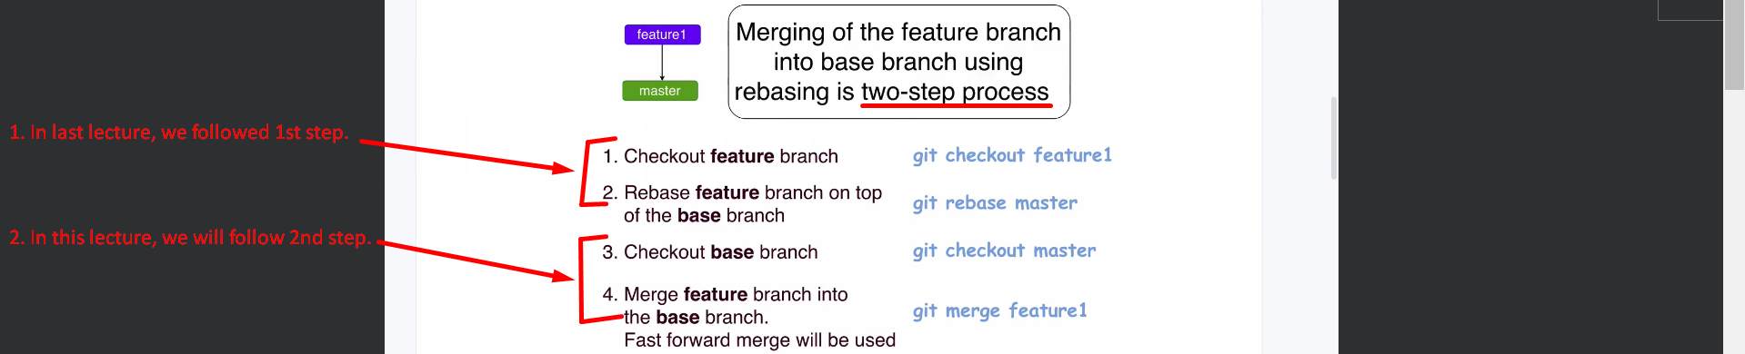
4. 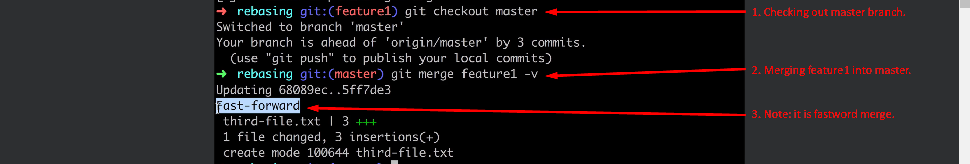
5. 